Task 1: CSS Processor
A CSS preprocessor is a scripting language that extends regular CSS, allowing developers to write more maintainable, scalable, and reusable styles. CSS preprocessors introduce features like variables, nested rules, functions, and mixins, which are not available in standard CSS. These preprocessors are then compiled into regular CSS that browsers can understand.

Popular CSS Preprocessors
- Sass (Syntactically Awesome Stylesheets):
  - Sass has two syntaxes: .sass (indented syntax) and .scss (similar to regular CSS).
- Less:
  - Less uses a syntax similar to CSS and is compiled on the client side or server side.
- Stylus:
  - Stylus offers a flexible syntax and can omit many of the braces, colons, and semicolons that are common in CSS.

Advantages of Using a CSS Preprocessor
- Variables: CSS preprocessors allow the use of variables for colors, font sizes, spacing, etc., making it easier to maintain and update styles globally.
- Nesting: They support nesting of selectors, which reflects the structure of HTML and makes the code more readable.
- Mixins: Preprocessors provide mixins, which allow the reuse of blocks of CSS code.
- Functions & Operations: They include built-in functions for color manipulation, math operations, and more, which helps with dynamic style calculations.
- Partials and Imports: CSS preprocessors allow splitting CSS into smaller files (partials) and importing them into a main file, improving file organization.
- Inheritance: They provide mechanisms to inherit styles between selectors, reducing redundancy.

Code Examples

1. Variables:
In standard CSS, you can't use variables:
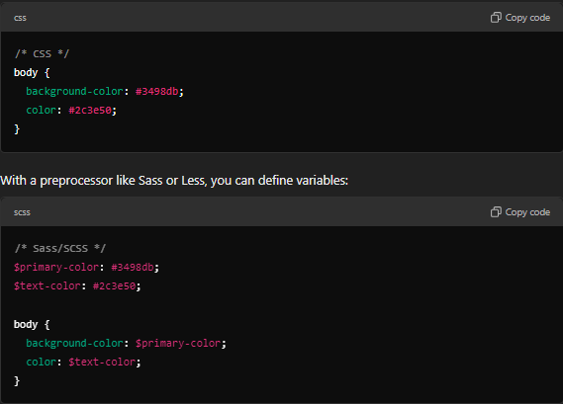
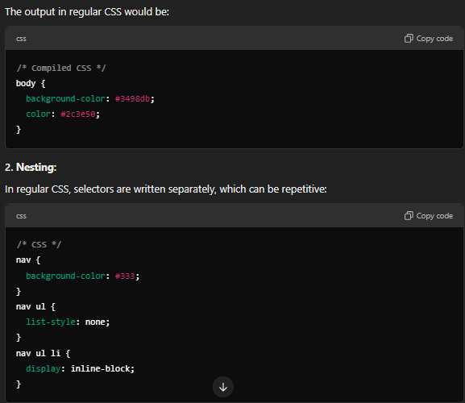
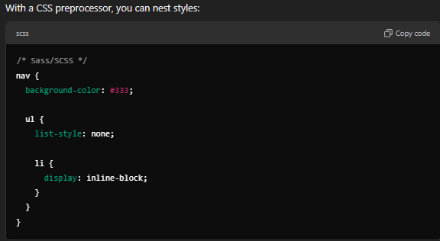
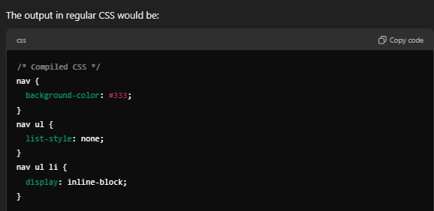
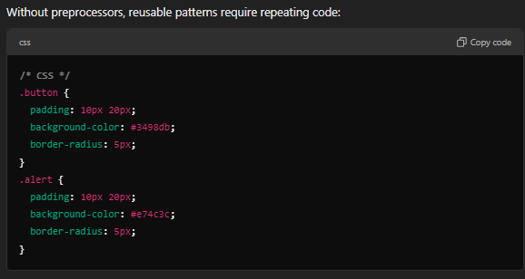
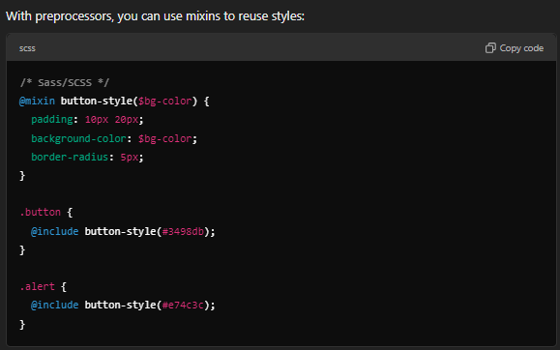
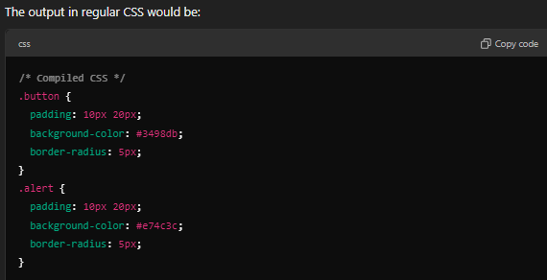

Conclusion
Using a CSS preprocessor simplifies CSS by adding powerful features like variables, nesting, and mixins, which can significantly improve maintainability and scalability. Preprocessors such as Sass, Less, and Stylus are widely adopted in web development because they reduce repetition, enhance productivity, and make stylesheets easier to manage and extend.

